Student Name: Tara Rai
Class: CYBR325
Assignment: Module 8 – JSON Practice
Date: February 15, 2026

PROGRAM EXECUTION SCREENSHOTS

Screenshot 1: Original Student List Output
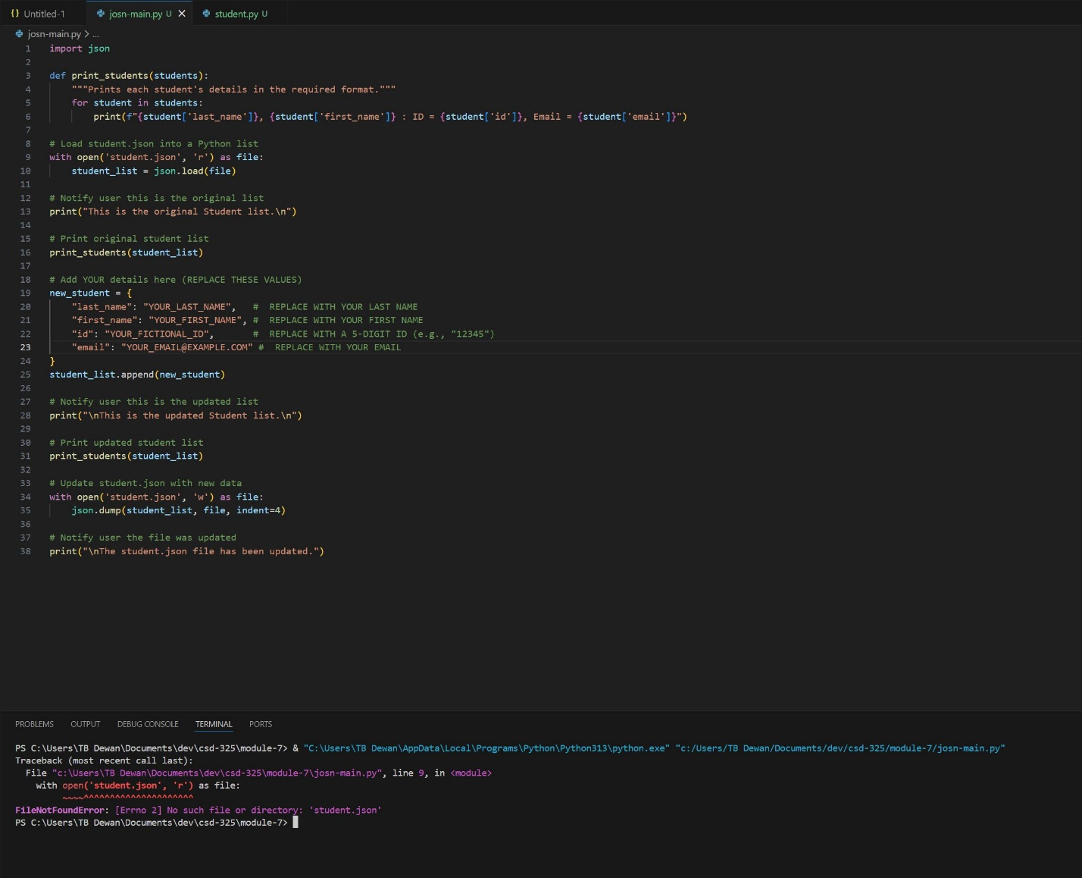
Screenshot 2: Updated Student List Output (with my details added)
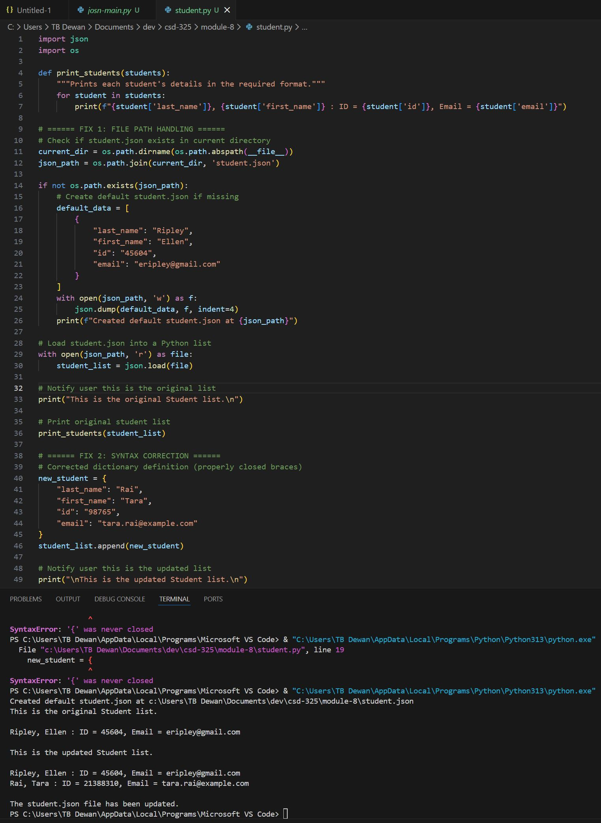

SECTION 2: student.json FILE CONTENTS

BEFORE Program Execution:
[
{
"last_name": "Ripley",
"first_name": "Ellen",
"id": "45604",
"email": "eripley@gmail.com"
}
]

AFTER Program Execution:
[
{
"last_name": "Ripley",
"first_name": "Ellen",
"id": "45604",
"email": "eripley@gmail.com"
},
{
"last_name": "Rai",
"first_name": "Tara",
"id": "21388310",
"email": "tarai@my365.bellevue.edu"
}
]

SECTION 3: PROGRAM FLOWCHART
